**CS205 C/ C++ Program Design**

**Assignment 1**

**Name**: 骆仕伟

**SID**: 21990005

## Part 1. Source Code

#include<string>

using namespace std;

int multiply(int x,int y)

{

int z;

z=x*y;

return z;

}

int main()

{

int a,b,t;

printf("Please input two integers:\n");

cin>>a>>b;

if(isalpha(a)!=0||isalpha(b)!=0)

{

printf(“wrong!”);

return 0；

}

t= multiply(a,b);

cout<<t;

return 0;

}

## Part 2. Result & Verification

In this part, you should present the result of your program by listing the output of test cases and optionally add a screen-shot of the result.

Test case #1:

2 3

Screen-short for case #1:

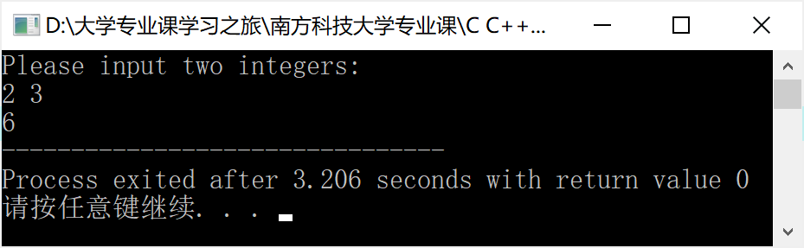

Test case #2:

a 2

Screen-short for case #2:

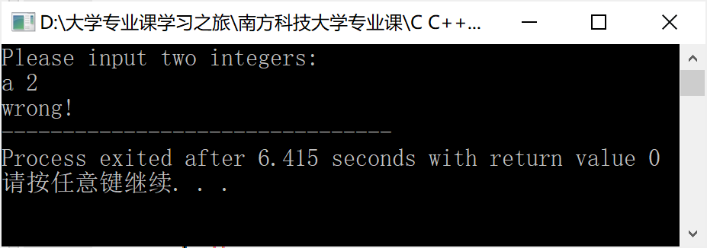

## Part 3. Difficulties & Solutions, or others

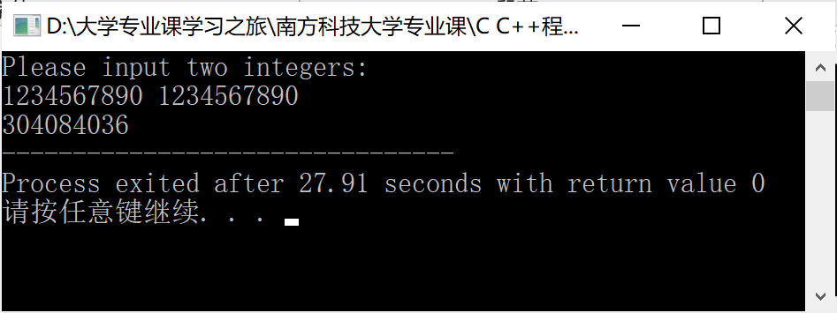

Difficulties ：

The answer is wrong! int 整型表达的数值范围有限 计算结果数值过大 发生了整型溢出问题

Solutions：

可以把int 改为 long long int